Beam Balance
# Source: AI Source: Provided by: [Data Path: Persons Table -> ID Column: 1, Name_En Column: Motasem Essam] -> From: [ChatGPT] on [7/17/2026]
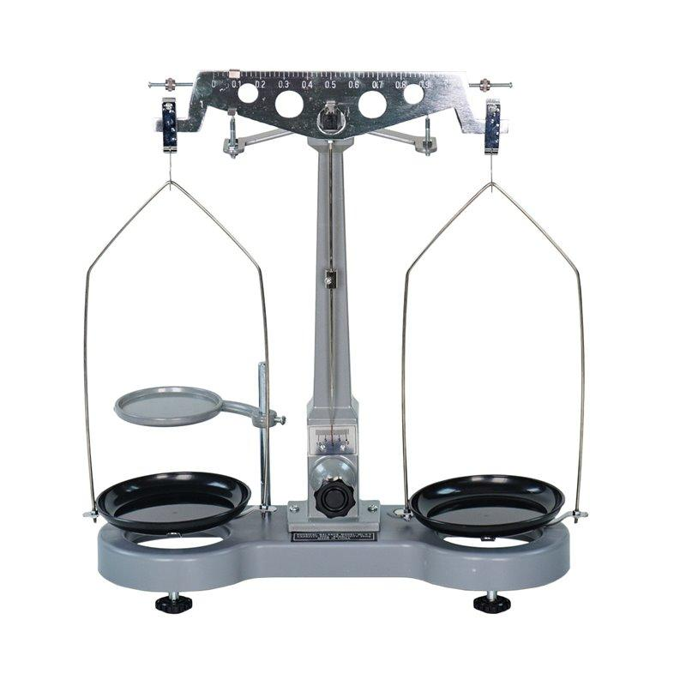
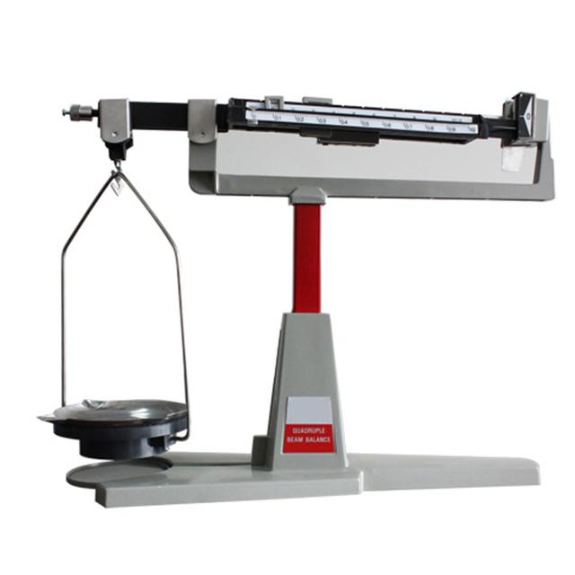
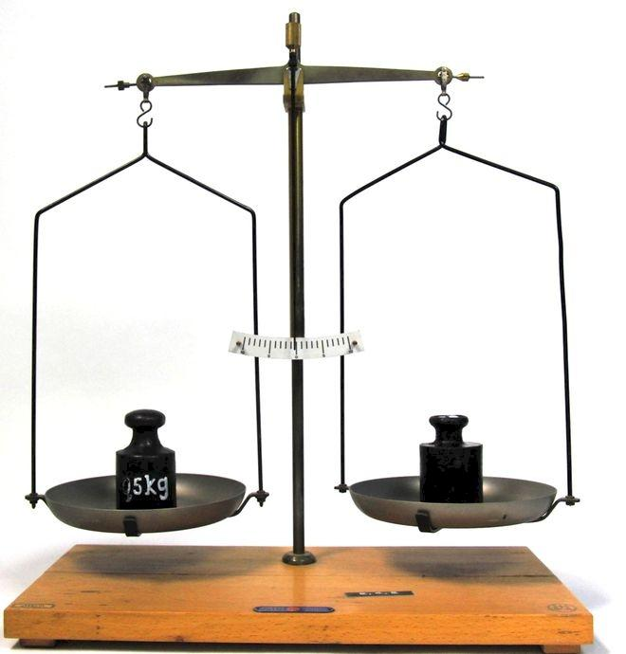
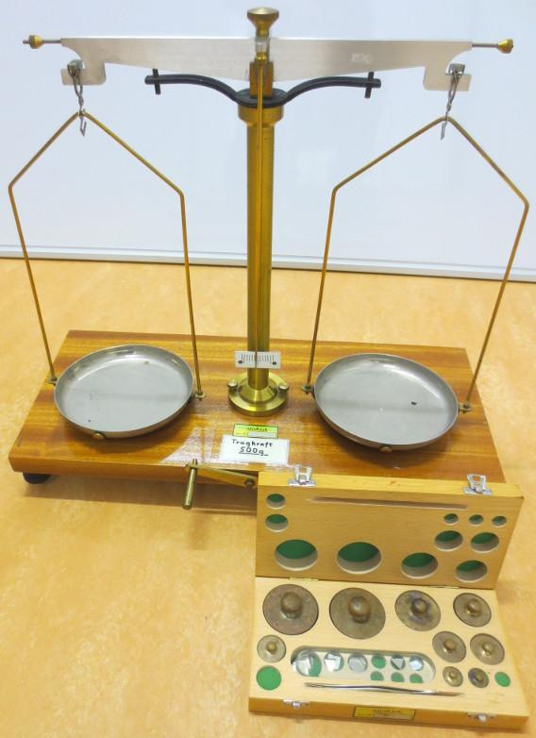
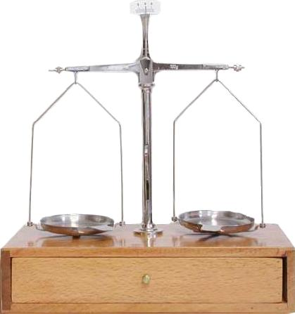
A Beam Balance is a mechanical measuring instrument used to determine the mass of an object by comparing it with known standard masses. It operates on the principle of moments (torque), where a horizontal beam balances when equal torques act on both sides.
Beam balances have been used for centuries and remain important for demonstrating the concept of mass comparison in education and laboratory settings.

Definition
# Source: AI Source: Provided by: [Data Path: Persons Table -> ID Column: 1, Name_En Column: Motasem Essam] -> From: [ChatGPT] on [7/17/2026]
A Beam Balance is a mechanical instrument used to measure the mass of an object by comparing it with known standard masses on opposite sides of a balanced beam.

Purpose
# Source: AI Source: Provided by: [Data Path: Persons Table -> ID Column: 1, Name_En Column: Motasem Essam] -> From: [ChatGPT] on [7/17/2026]
A Beam Balance is used to:
- Measure mass.
- Compare masses.
- Demonstrate the principle of balance.
- Perform educational laboratory experiments.
- Verify standard masses.
- Conduct simple scientific measurements.

Principle of Operation
# Source: AI Source: Provided by: [Data Path: Persons Table -> ID Column: 1, Name_En Column: Motasem Essam] -> From: [ChatGPT] on [7/17/2026]
A beam balance works on the principle of equal moments.
When the torque produced by the object equals the torque produced by the standard masses, the beam becomes horizontal.
The condition for balance is:
$$\boxed{m_{1}gL_{1}=m_{2}gL_{2}}$$
For an equal-arm beam balance:
$$\boxed{m_{1}=m_{2}}$$
where:
- $m$= mass
- $g$= gravitational acceleration
- $L$= distance from the pivot
Since both arms have equal length, equal masses produce equal torques.

Main Components
# Source: AI Source: Provided by: [Data Path: Persons Table -> ID Column: 1, Name_En Column: Motasem Essam] -> From: [ChatGPT] on [7/17/2026]
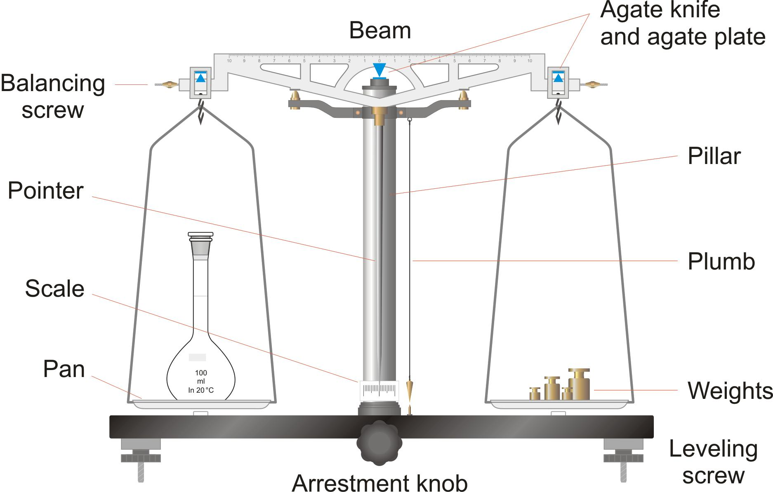
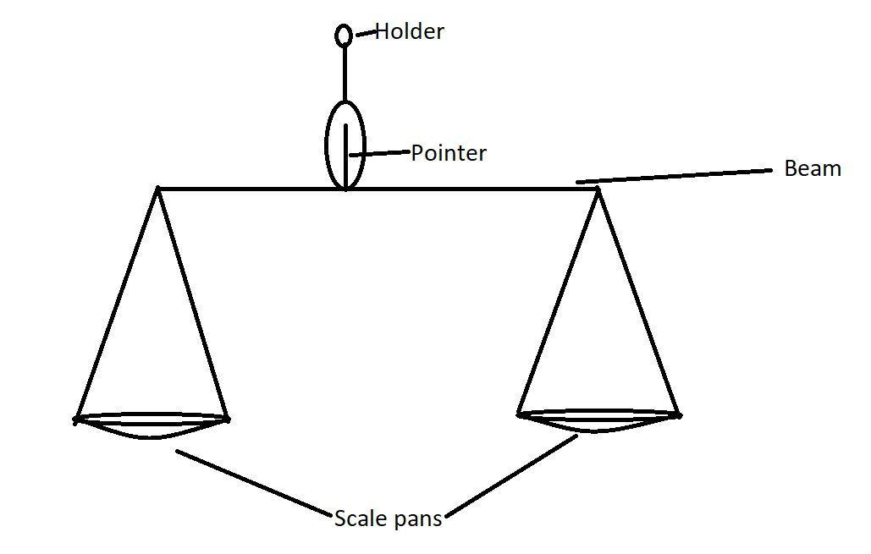
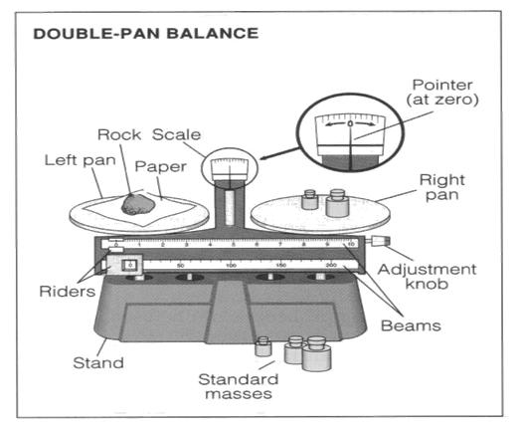
A typical Beam Balance consists of:
- Horizontal beam
- Central pivot (fulcrum)
- Two weighing pans
- Pointer (indicator)
- Graduated support or index
- Base
- Knife-edge bearings (precision models)

Types of Beam Balances

1. Equal-Arm Beam Balance
# Source: AI Source: Provided by: [Data Path: Persons Table -> ID Column: 1, Name_En Column: Motasem Essam] -> From: [ChatGPT] on [7/17/2026]
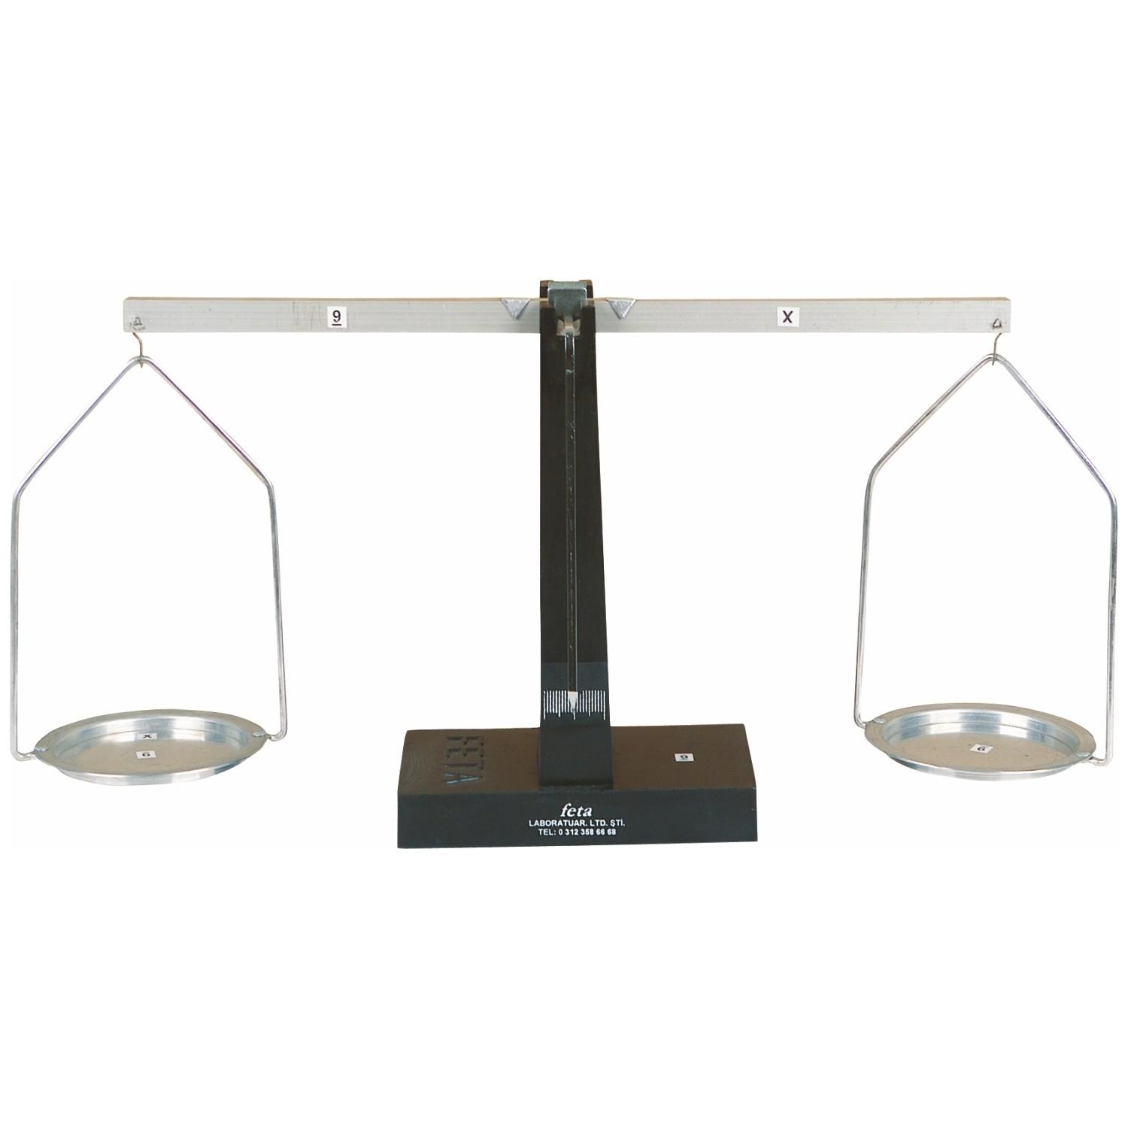

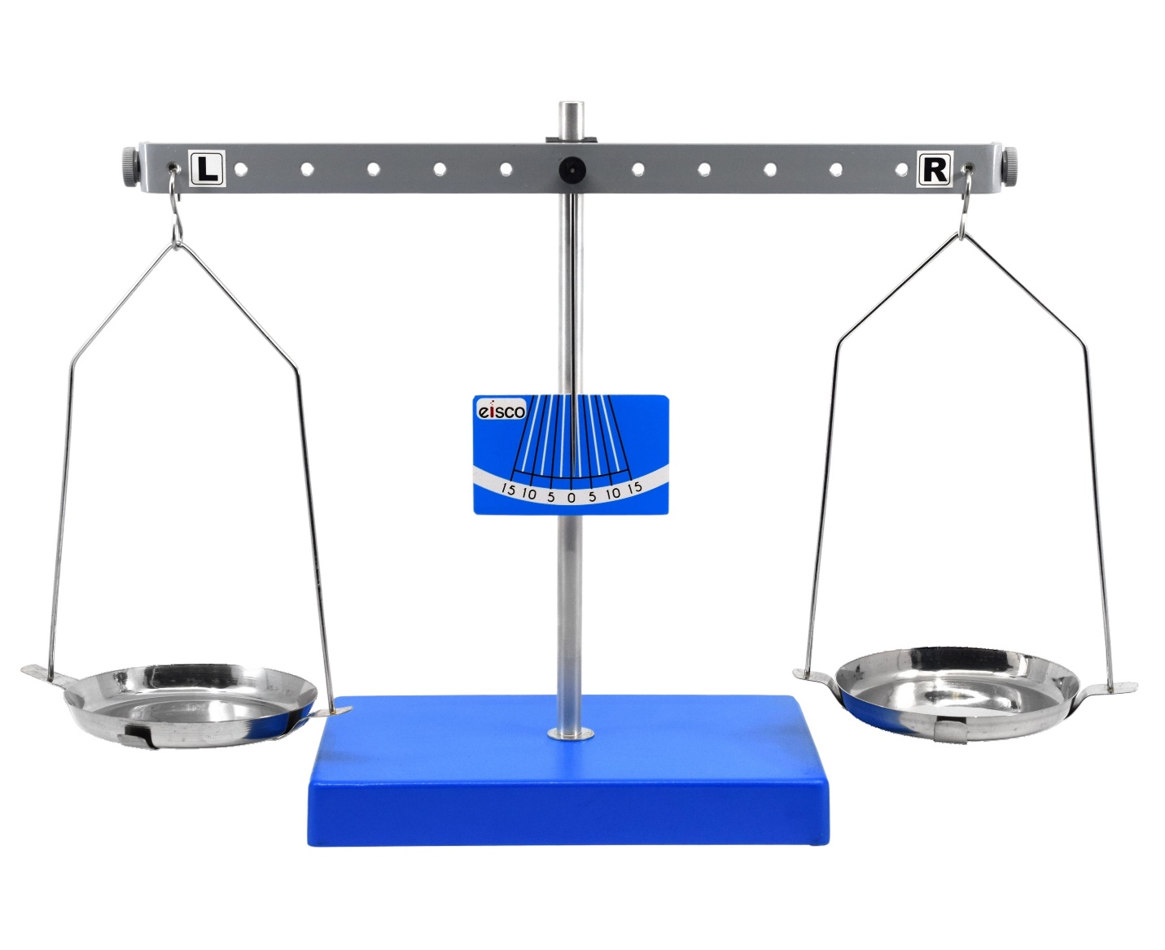
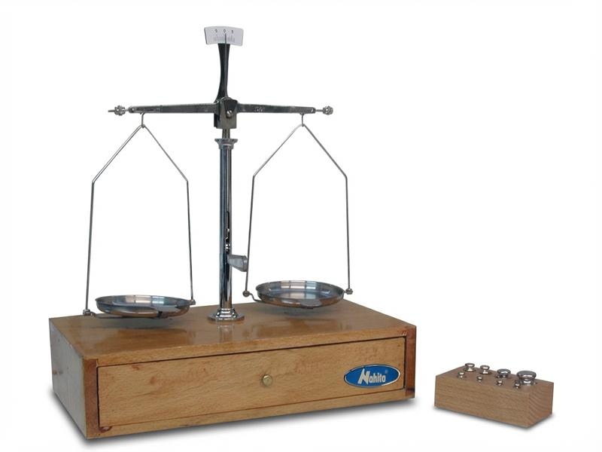
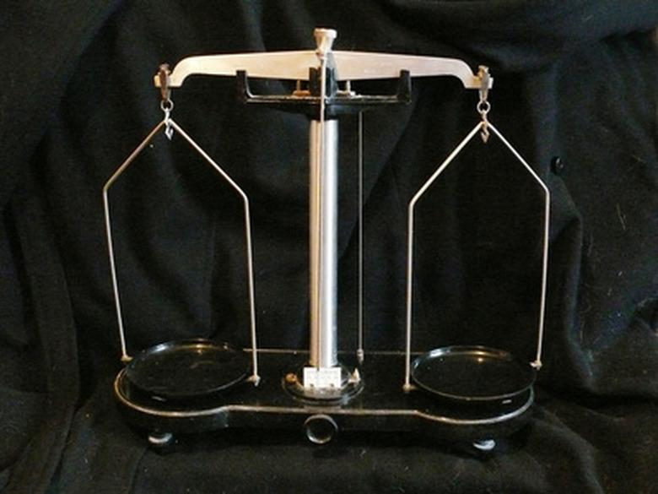
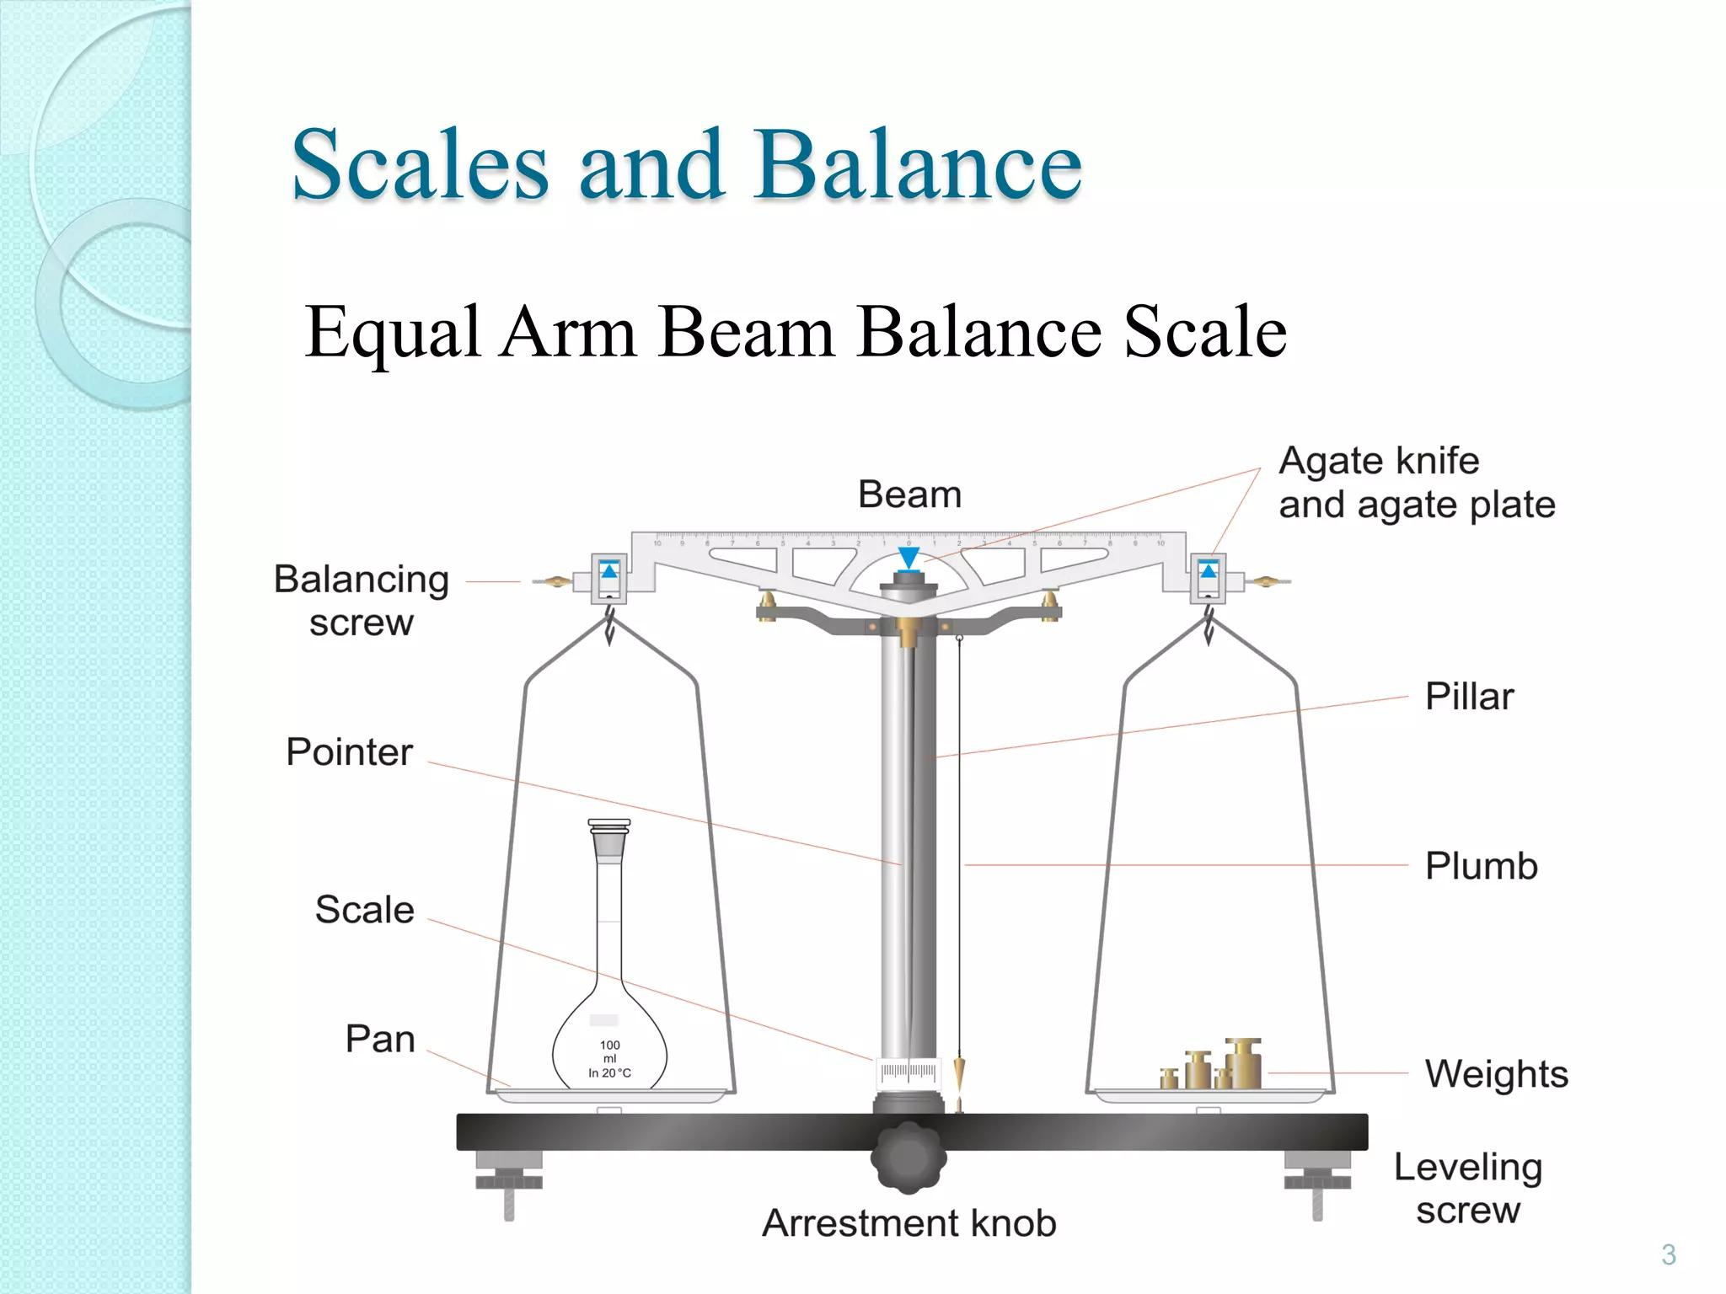
Description
Both pans are at equal distances from the pivot.
Features
- Highest accuracy among mechanical balances
- Direct comparison of masses
- Requires standard weights
Applications
- Scientific laboratories
- Educational demonstrations
- Calibration work

2. Laboratory Beam Balance
# Source: AI Source: Provided by: [Data Path: Persons Table -> ID Column: 1, Name_En Column: Motasem Essam] -> From: [ChatGPT] on [7/17/2026]
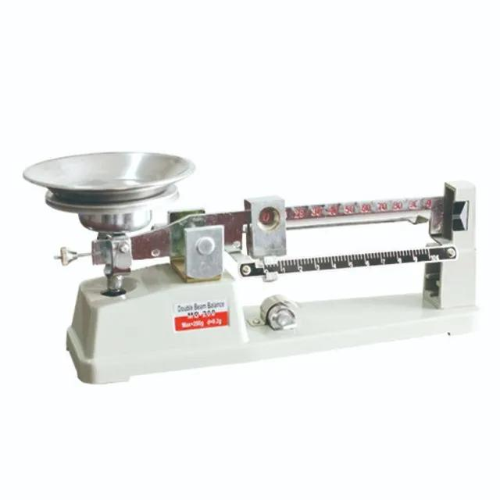

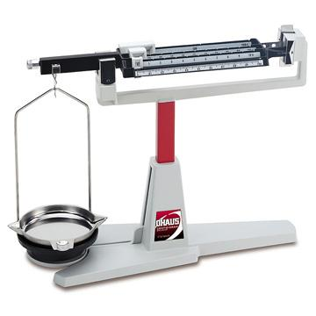
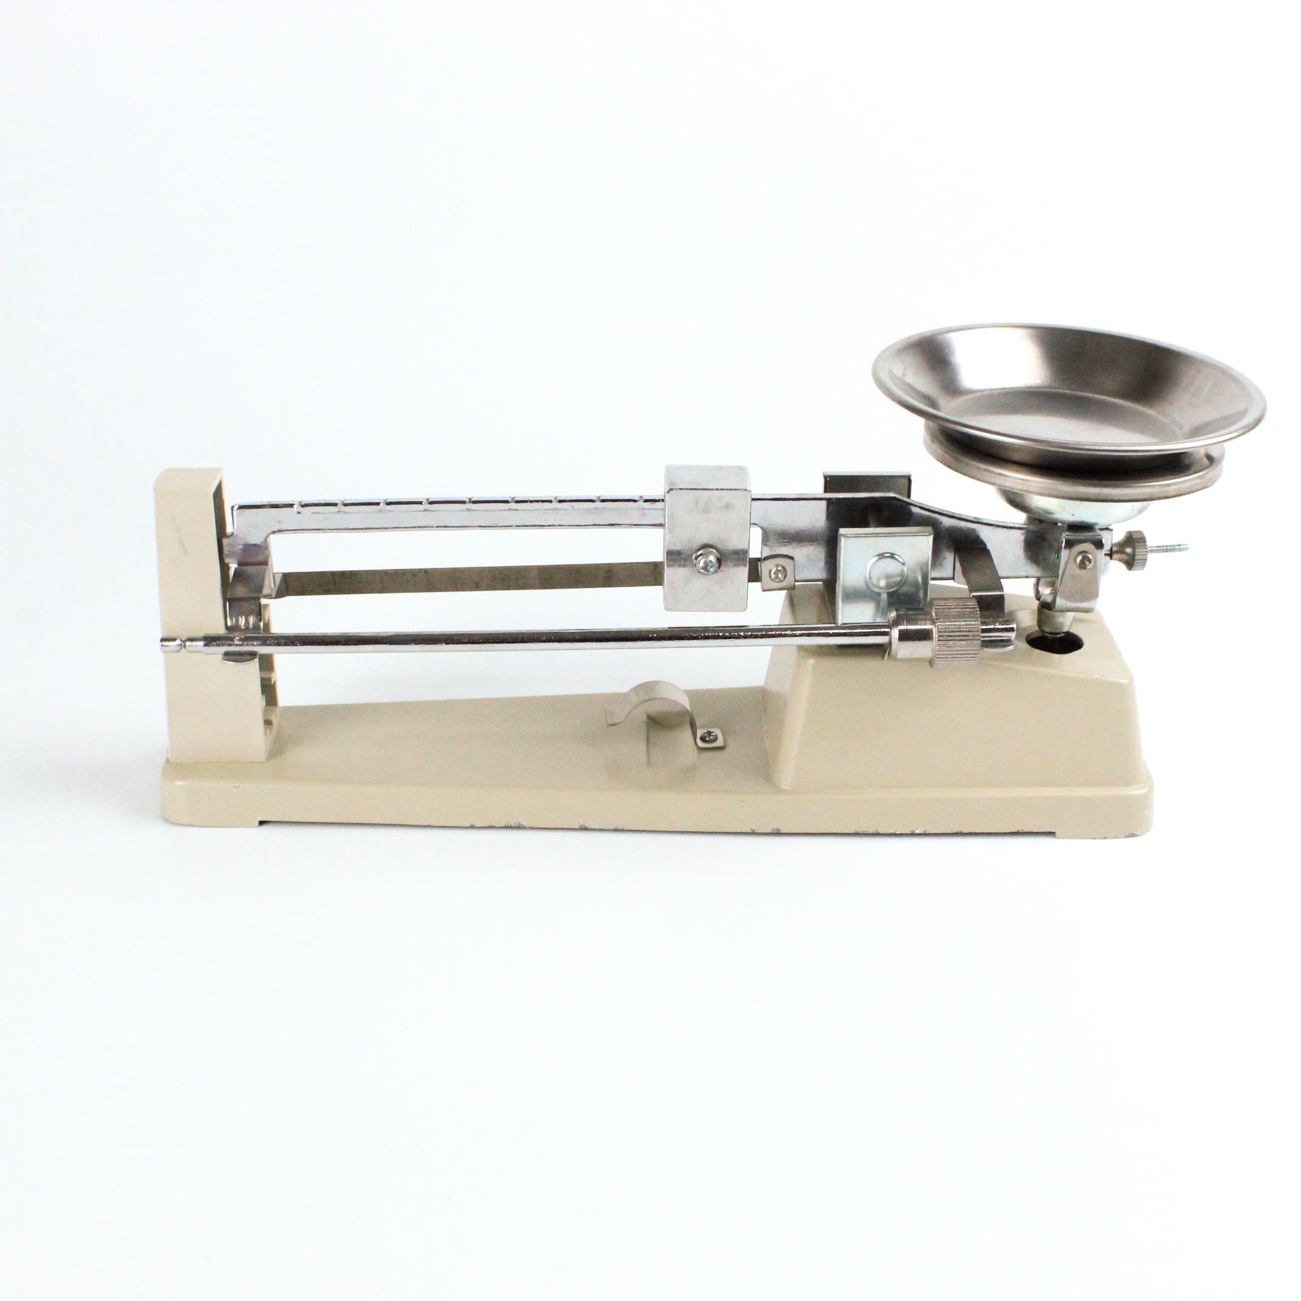
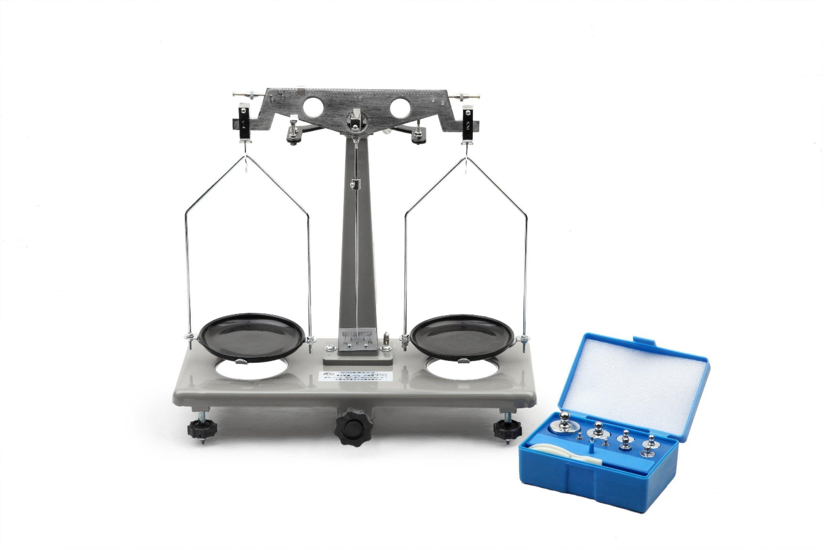
Description
Designed for laboratory use with improved sensitivity and precision.
Applications
- Chemistry laboratories
- Physics laboratories
- Educational institutions

3. Roberval Beam Balance
# Source: AI Source: Provided by: [Data Path: Persons Table -> ID Column: 1, Name_En Column: Motasem Essam] -> From: [ChatGPT] on [7/17/2026]
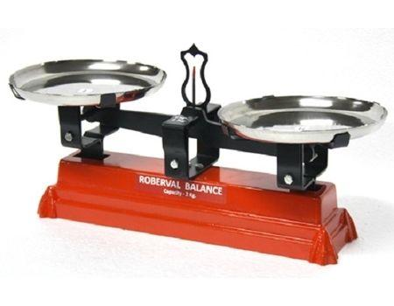
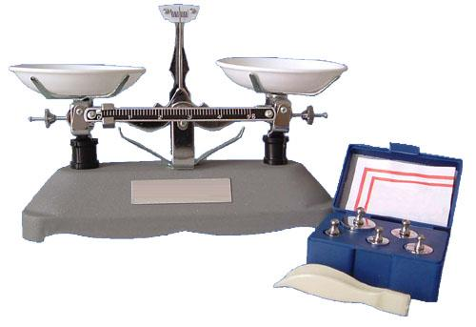
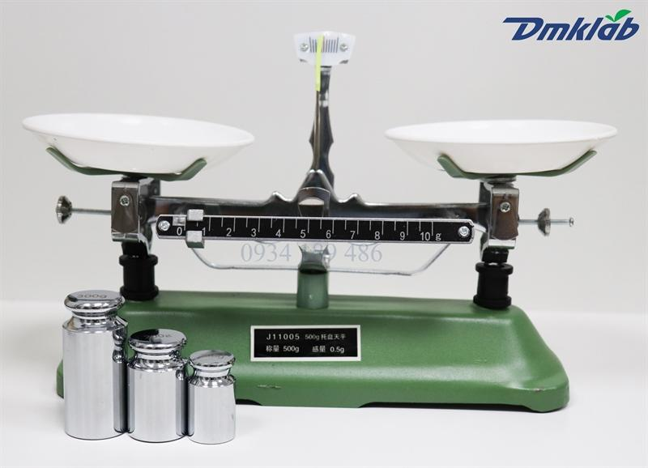
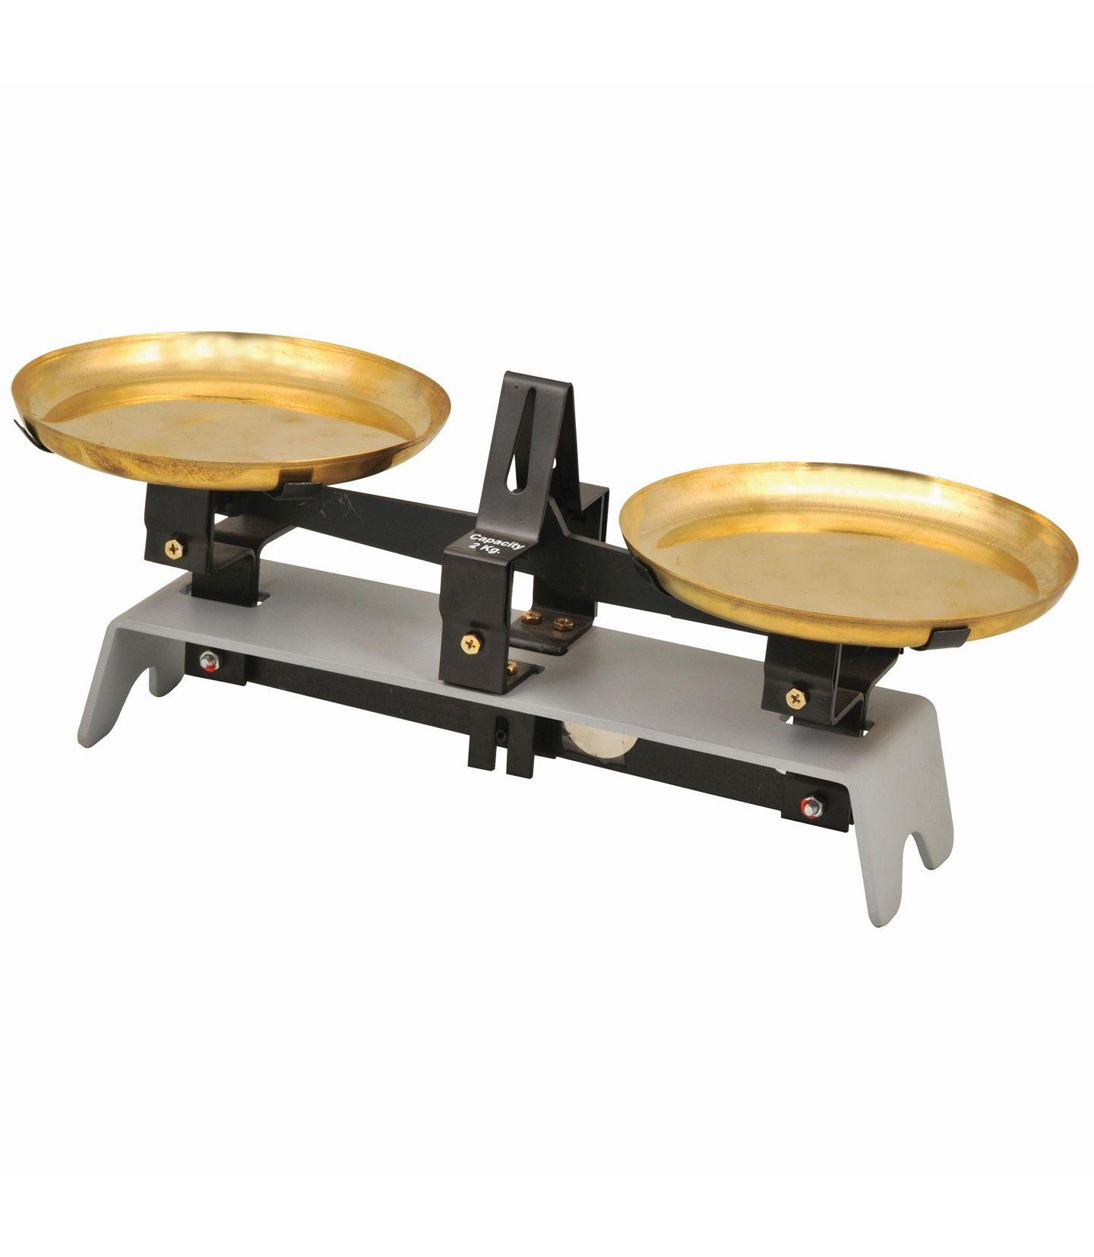

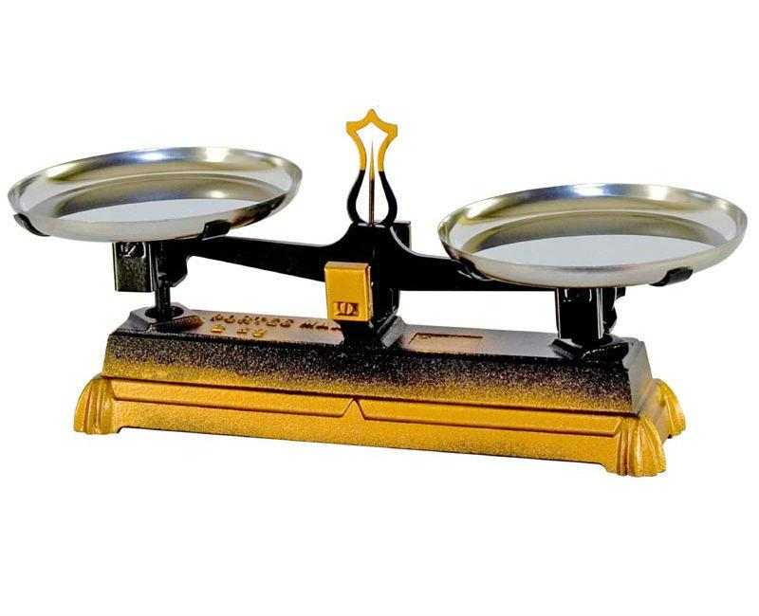
Description
A compact beam balance in which the pans remain level regardless of where the object is placed.
Applications
- Commercial weighing
- Retail stores (historically)
- Educational use

Measuring Units
# Source: AI Source: Provided by: [Data Path: Persons Table -> ID Column: 1, Name_En Column: Motasem Essam] -> From: [ChatGPT] on [7/17/2026]
Beam balances measure:
- Gram (g)
- Kilogram (kg)
- Milligram (mg) (with appropriate weights)

Measuring Range
# Source: AI Source: Provided by: [Data Path: Persons Table -> ID Column: 1, Name_En Column: Motasem Essam] -> From: [ChatGPT] on [7/17/2026]
Typical capacities:
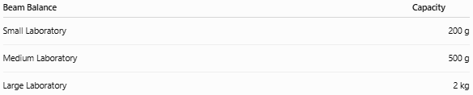
Beam Balance | Capacity
Small Laboratory | 200 g
Medium Laboratory | 500 g
Large Laboratory | 2 kg

Resolution
# Source: AI Source: Provided by: [Data Path: Persons Table -> ID Column: 1, Name_En Column: Motasem Essam] -> From: [ChatGPT] on [7/17/2026]
Typical resolution depends on the balance design:
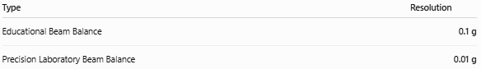
Type | Resolution
Educational Beam Balance | 0.1 g
Precision Laboratory Beam Balance | 0.01 g

How to Measure Mass
# Source: AI Source: Provided by: [Data Path: Persons Table -> ID Column: 1, Name_En Column: Motasem Essam] -> From: [ChatGPT] on [7/17/2026]
- Ensure the balance is level and the pointer is at zero.
- Place the unknown object on one pan.
- Place standard masses on the opposite pan.
- Adjust the masses until the beam is perfectly horizontal.
- Add the values of the standard masses.
- Record the object's mass.

Example
# Source: AI Source: Provided by: [Data Path: Persons Table -> ID Column: 1, Name_En Column: Motasem Essam] -> From: [ChatGPT] on [7/17/2026]
Suppose balance is achieved using:
- 100 g
- 20 g
- 5 g
Total mass:
$$100+20+5=125\text{ g}$$
The object's mass is:
125 g

Accuracy
# Source: AI Source: Provided by: [Data Path: Persons Table -> ID Column: 1, Name_En Column: Motasem Essam] -> From: [ChatGPT] on [7/17/2026]
Accuracy depends on:
- Knife-edge quality
- Beam symmetry
- Calibration
- Standard weights
- Proper leveling
High-quality laboratory beam balances can achieve excellent accuracy because they compare masses directly.

Sources of Error
# Source: AI Source: Provided by: [Data Path: Persons Table -> ID Column: 1, Name_En Column: Motasem Essam] -> From: [ChatGPT] on [7/17/2026]
Instrument Errors
- Worn knife edges
- Bent beam
- Unequal arm lengths
- Damaged pans

Observation Errors
- Misreading the pointer
- Not waiting for the beam to stabilize

Positioning Errors
- Object placed improperly
- Standard weights stacked unsafely
- Balance not leveled

Environmental Errors
- Air currents
- Vibrations
- Dust
- Mechanical friction

Applications
# Source: AI Source: Provided by: [Data Path: Persons Table -> ID Column: 1, Name_En Column: Motasem Essam] -> From: [ChatGPT] on [7/17/2026]
Beam Balances are used in:
- Physics laboratories
- Chemistry laboratories
- Schools
- Universities
- Scientific demonstrations
- Calibration laboratories
- Historical scientific measurements

Advantages
# Source: AI Source: Provided by: [Data Path: Persons Table -> ID Column: 1, Name_En Column: Motasem Essam] -> From: [ChatGPT] on [7/17/2026]
A Beam Balance:
- Measures mass directly by comparison.
- Is independent of local gravitational strength when both sides experience the same gravity.
- Requires no electricity.
- Is durable.
- Provides excellent educational value.

Limitations
# Source: AI Source: Provided by: [Data Path: Persons Table -> ID Column: 1, Name_En Column: Motasem Essam] -> From: [ChatGPT] on [7/17/2026]
A Beam Balance:
- Operates more slowly than electronic balances.
- Requires standard masses.
- Cannot automatically display readings.
- Is sensitive to vibration.
- Has lower productivity than digital balances.

Comparison with Other Mass Measuring Instruments
# Source: AI Source: Provided by: [Data Path: Persons Table -> ID Column: 1, Name_En Column: Motasem Essam] -> From: [ChatGPT] on [7/17/2026]
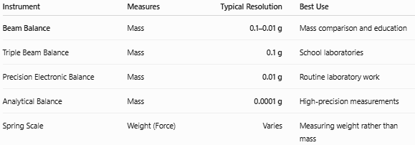
Instrument | Measures | Typical Resolution | Best Use
Beam Balance | Mass | 0.1–0.01 g | Mass comparison and education
Triple Beam Balance | Mass | 0.1 g | School laboratories
Precision Electronic Balance | Mass | 0.01 g | Routine laboratory work
Analytical Balance | Mass | 0.0001 g | High-precision measurements
Spring Scale | Weight (Force) | Varies | Measuring weight rather than mass

Care and Maintenance
# Source: AI Source: Provided by: [Data Path: Persons Table -> ID Column: 1, Name_En Column: Motasem Essam] -> From: [ChatGPT] on [7/17/2026]
To maintain accuracy:
- Keep the beam clean.
- Handle standard masses carefully.
- Avoid overloading the pans.
- Protect knife edges from damage.
- Store in a dry, dust-free environment.
- Check zero before every measurement.

Common Mistakes
# Source: AI Source: Provided by: [Data Path: Persons Table -> ID Column: 1, Name_En Column: Motasem Essam] -> From: [ChatGPT] on [7/17/2026]
- Confusing mass with weight.
- Not zeroing the balance before use.
- Using damaged standard weights.
- Reading the balance before it stabilizes.
- Measuring on an uneven surface.

Key Points
# Source: AI Source: Provided by: [Data Path: Persons Table -> ID Column: 1, Name_En Column: Motasem Essam] -> From: [ChatGPT] on [7/17/2026]
- A Beam Balance measures mass by comparison.
- It operates using the principle of equal moments (torque).
- Common types:
  - Equal-Arm Beam Balance
  - Laboratory Beam Balance
  - Roberval Beam Balance
- Typical resolution:
  - 0.1 g
  - 0.01 g (precision models)
- It is widely used in education, laboratories, and scientific demonstrations.

Conclusion
# Source: AI Source: Provided by: [Data Path: Persons Table -> ID Column: 1, Name_En Column: Motasem Essam] -> From: [ChatGPT] on [7/17/2026]
A Beam Balance is a classic mechanical instrument for measuring mass by comparing an unknown object with known standard masses. Because it relies on the principle of equal moments, it provides reliable and accurate mass measurements without requiring electrical power. Although electronic balances are now more common in many laboratories, beam balances remain valuable in education, scientific demonstrations, calibration, and situations where direct mass comparison is preferred.

